LAB 3 EXPERIMENT

1.Write a C program to calculate the total bill for a customer's grocery purchase. The program should ask the user to input the price and quantity of three different items. It should then calculate the total cost for each item by multiplying price and quantity and finally display the total bill

#include <stdio.h>
int main(){
float p1,p2,p3;
int q1,q2,q3;
float total1,total2,total3,totalbill;
printf("enter the price of item1: ");
scanf("%f",&p1);
printf("enter the quantity of item1: ");
scanf("%d",&q1);
printf("enter the price of item2: ");
scanf("%f",&p2);
printf("enter the quantity of item2: ");
scanf("%d",&q2);
printf("enter the price of item3: ");
scanf("%f",&p3);
printf("enter the quantity of item3: ");
scanf("%d",&q3);
total1=p1*q1;
total2=p2*q2;
total3=p3*q3;
totalbill=total1+total2+total3;
printf("the total cost for item1 is %.2f",total1);
printf("the total cost for item2 is %.2f",total2);
printf("the total cost for item3 is %.2f",total3);
printf("totalbill =%.2fn",totalbill);
return 0;
}

OUTPUT:
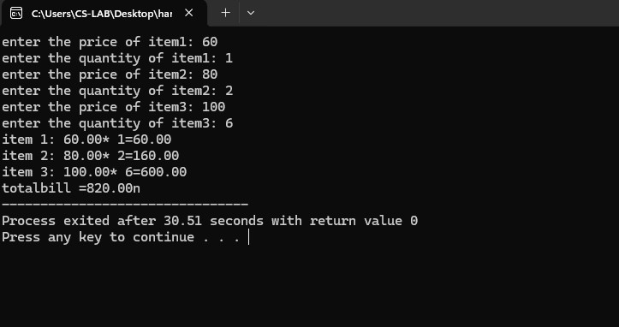

2.Write a C program that simulates an ATM withdrawal. The program should: Prompt the user to enter the current account balance and the withdrawal amount. Check if the withdrawal amount is less than or equal to the account balance. ○ If yes, deduct the amount from the balance and display the new balance. If no, display a message indicating insufficient funds.

#include <stdio.h>
int main() {
float accBal, withdrawalAmt;
printf("Enter your current account balance: ");
scanf("%f", &accBal);
printf("Enter the amount to withdraw: ");
scanf("%f", &withdrawalAmt);
if (withdrawalAmt <= accBal) {
accBal -= withdrawalAmt;
printf("Withdrawal successful! New balance: %f.\n", accBal);
} else {
printf("Insufficient funds. Cannot withdraw %f.\n", withdrawalAmt);
}
return 0;
}
OUTPUT:
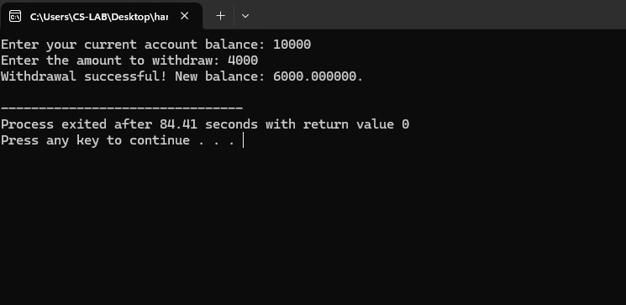

3.Write a C program to check whether the year is a leap year or not.

#include <stdio.h>
int main() {
int yr;
printf("Enter a yr: ");
scanf("%d", &yr);
if ((yr % 4 == 0 && yr % 100 != 0)|| (yr % 400 == 0)) {
printf("%d is a leap yr.\n", yr);
} else {
printf("%d is not a leap yr.\n", yr);
}
return 0;
}

OUTPUT:

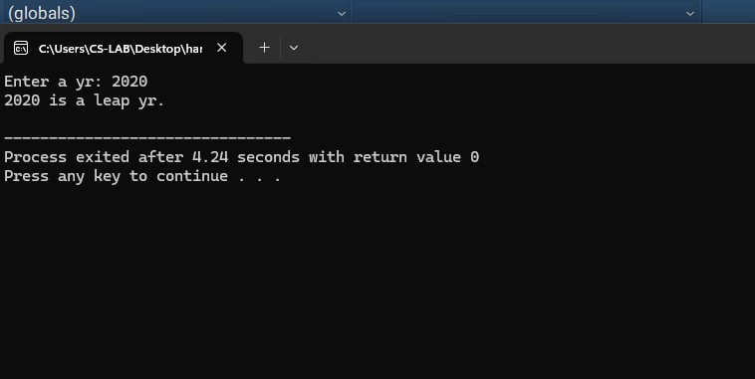

4.Write a C Program to Classify a Character as Vowel or Consonant

#include <stdio.h>
int main() {
char ch;
printf("Enter a character: ");
scanf("%c", &ch);
if (ch == 'a' || ch == 'e' || ch == 'i' || ch == 'o' || ch == 'u' ||
ch == 'A' || ch == 'E' || ch == 'I' || ch == 'O' || ch == 'U') {
printf("%c is a vowel.\n", ch);
} else {
printf("%c is a consonant.\n", ch);
}
return 0;
}

OUTPUT:

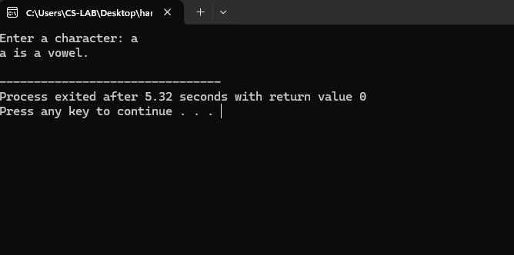

5.Write a C program to find the square root of a number
#include <stdio.h>
#include <math.h>
int main()
{
float num, root;
printf("Enter a number to find the square root: ");
scanf("%f", &num);
root = sqrt(num);
printf("Square root of %.2f = %.2f", num, root);
return 0;
}

OUTPUT:
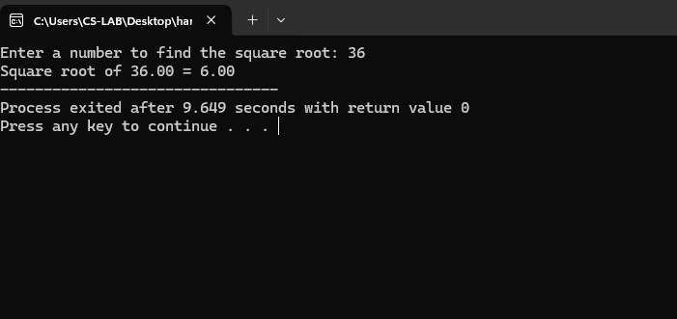

6.Write a C program to find odd or even number using ternary operator.

#include <stdio.h>
int main() {
int num = 10;
(num % 2 == 0) ? printf("Even Number") : printf("Odd Number");
return 0;
}

OUTPUT:

7.Write a C program to calculate the final price of an item with a discount. The user should input the original price, the discount percentage, and the sales tax percentage. The final price should be calculated as follows: final_price = (original_price - (original_price * discount/100)) * (1 +tax/100) Demonstrate how to correctly handle operator precedence in this
calculation.

int main() {
float org_price, disc, tax, final_price;
printf("Enter the orginal price: ");
scanf("%f", &org_price);
printf("Enter the discount percentage: ");
scanf("%f", &disc);
printf("Enter the sales tax percentage: ");
scanf("%f", &tax);
final_price = org_price - (org_price * (disc / 100));
final_price = final_price * (1 + (tax / 100));
printf("The final price is: $%.2f\n", final_price);
return 0;
}

OUTPUT:

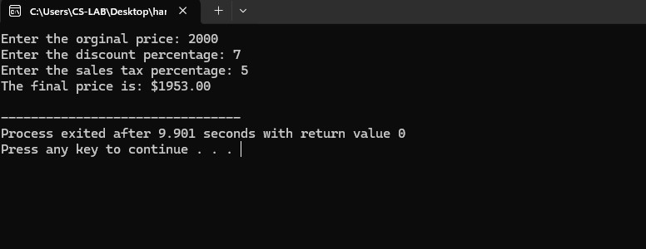

8.Write a C program to demonstrate the increment and decrement operators.

#include <stdio.h>
int main() {
int a = 6, b = 11, result;
result = ++a + b++ + a++;
printf("Result = %d\n", result);
printf("a = %d, b = %d\n", a, b);
return 0;
}

OUTPUT:

